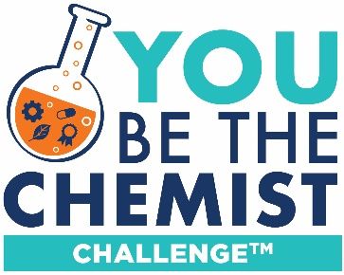
You Be The Chemist Challenge®
Video Storyboard Template

This storyboard can be filled out in Microsoft Word or Google Drive, or printed and completed by hand and scanned in.

Your storyboard provides evidence of your team’s planning process for the judges of the video component of the Challenge. The teams that advance to the National Challenge will present the visuals and text taken directly from these storyboards to determine the National You Be The Chemist Challenge first, second, and third place teams.

Storyboard Guidelines and Requirements:
- For the national-level competition, storyboards will be judged based on content, not artistic ability. However, keep in mind that the images and text should still be visually interesting and clear.
- Use the Details and Notes section to organize your team’s general ideas for the video.
- Use this Storyboard Scene Planning to guide your video’s story and structure. Each team must create at least one storyboard panel for each of the following video components (you can make more than one storyboard panel for any section but must include at least one):
  - Opening titles
  - Explanation of the core concept
  - Representation of phenomena and explanation concept connection (at least 1 panel for each phenomenon)
  - Description of chosen career and education path
  - Closing titles
With the exception of the opening and closing titles, these components do not need to follow the specific order above, but the order must make logical sense and be easy to follow for video audience.
- For each storyboard panel:
  - Provide sketches or relevant images of each scene in the box. Images can be hand-drawn, or photographs your team has taken, or copied and pasted images (all copied and pasted images must comply with copyright rules and regulations described in the Video Guidelines)
  - Outline relevant dialogue or narrative in the space provided underneath each box. These notes do not have to be a word-for-word script (it can be if your team wants it to be!) but should provide details about what will be said in the scene.

Details and Notes:
School Name and Address:
Team Member Names:

Video Title:

Phenomena Identified (very brief description of each):

Selected Career and Training Path (brief description):

Scene # and component:

Dialogue/Narrative:

Scene # and component:

Dialogue/Narrative:

Scene # and component:

Dialogue/Narrative:

Scene # and component:

Dialogue/Narrative:

Scene # and component:

Dialogue/Narrative:

Scene # and component:

Dialogue/Narrative:

Scene # and component:

Dialogue/Narrative:

Scene # and component:

Dialogue/Narrative:

Scene # and component:

Dialogue/Narrative:

Scene # and component:

Dialogue/Narrative:

Scene # and component:

Dialogue/Narrative:

Scene # and component:

Dialogue/Narrative:

