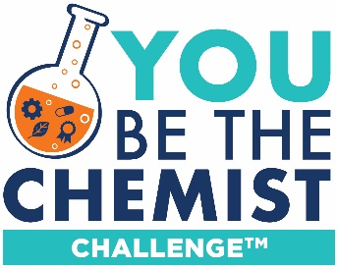
You Be The Chemist Challenge®
Video Storyboard Template

This storyboard should be included with each team’s video submission.

Your storyboard should guide your team’s video creation process. The storyboard provides evidence of your team’s planning process for the judges of the video component of the Challenge.

Storyboard Guidelines and Requirements:
- Use this Storyboard Template to guide your video’s story and structure: You must submit a completed storyboard with your video submission. Each team’s video should include the following based on the Video Guidelines and the Video Rubric:
  - Opening titles
  - Introduction to start-up company
  - Explanation of problem
  - Presentation of innovative solution
  - Clear embedding of identified career/job roles in discussions of problem and solution
  - Closing titles
Note- With the exception of the opening and closing titles, these components do not need to follow the specific order above, but the order must make logical sense and be easy to follow for video audience.
- For each storyboard component:
  - Complete the details in each box (please refer to the rubric)
  - Outline relevant dialogue or narrative in the space provided underneath each box. These notes do not have to be a word-for-word script (it can be if your team wants it to be!).

Details and Notes:
School Name and Address:
Team ID:

Team Member Names:

Video Title:

This storyboard includes time recommendations for each section; however, sections within a video do not have to follow these suggestions. Please note, videos that are not between 5.0-7.0 minutes total will not be scored.

Explanation of Start-Up (1-1.5 minutes)

Company Name:

Company Mission:

Company Role:

Careers:

Company Details - Dialogue/Narrative (Please use this space as a guide to create your dialogue/narrative. Your final video product can differ.)

Explanation of Problem (2-2.5 minutes)

Problem Identified:

Core Chemistry Concepts – Forces and Interactions:

Connection between problem and chemistry concepts:

Impact:

Connection between career(s) and problem:

Explanation of Problem - Dialogue/Narrative (Please use this space as a guide to create your dialogue/narrative. Your final video product can differ.)

Innovative Solution (2-3 minutes)

Innovative Solution:

How solution addresses the problem:

Core Chemistry Concepts – Forces and Interactions:

Addressing Sustainability:

Strengths and Obstacles:

Strengths Obstacles

Connection between career(s) and solution:

Depiction of Solution:

Explanation of Solution - Dialogue/Narrative (Please use this space as a guide to create your dialogue/narrative. Your final video product can differ.)

Citations (APA format):

