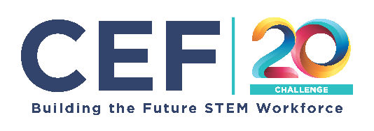
2023-2024 You Be The Chemist Challenge®
Video Storyboard Template

This storyboard should be included with each team’s video submission.
Although many file types are accepted, .pdf and .doc filles preferred.

Your storyboard should guide your team’s video creation process. The storyboard provides evidence of your team’s planning process for the judges of the video component of the Challenge.

Storyboard Guidelines and Requirements:
- Use this Storyboard Template to guide your video’s story and structure: You must submit a completed storyboard with your video submission. Each team’s video should include the following based on the Video Guidelines and the Video Rubric:
  - Opening titles
  - Introduction to start-up company
  - Explanation of problem
  - Presentation of innovative solution
  - Clear embedding of identified career/job roles that represent diverse educational backgrounds in discussions of problem and solution
  - Closing titles
Note- With the exception of the opening and closing titles, these components do not need to follow the specific order above, but the order must make logical sense and be easy to follow for video audience.
- For each storyboard component:
  - Complete the details in each box (please refer to the rubric)
  - Outline relevant dialogue or narrative in the space provided underneath each box. These notes do not have to be a word-for-word script (it can be if your team wants it to be!).

Opening Title:
Video Title:
Challenge Theme:
School Name:
School Address:
Team ID:

Closing Title:
School Name:
Team Members:
Member Name (first name and last initial) Member Contribution

Please note, videos that do not have opening and closing titles will not be scored.

This storyboard includes time recommendations for each section; however, sections within a video do not have to follow these suggestions. Please note, videos that are not between 5-7 minutes total will not be scored.

Explanation of Start-Up (1-1.5 minutes)

Company Name:

Company Mission:

Description of Company Industry:

Careers and Educational Level:
Please note, videos that do not feature a minimum of three careers (one of which must be from skill-trades/certifications) will not be scored

Company Details - Dialogue/Narrative (Please use this space as a guide to create your dialogue/narrative. Your final video product can differ.)

Sketch of the scene:

Explanation of Problem (2-2.5 minutes)

Problem Identified:

Core Chemistry Concepts – Life Science:

Impact:

Explanation of Problem - Dialogue/Narrative (Please use this space as a guide to create your dialogue/narrative. Your final video product can differ.)

Sketch of the scene:

Innovative Solution (2-3 minutes)

Innovative Solution:

How solution addresses the problem:

Core Chemistry Concepts – Life Science:

Connection between solution and chemistry concepts:

Addressing Sustainability:

United Nation SDG addressed:

Strengths and Obstacles:

Strengths Obstacles

Connection between career(s) and solution:

Visual of Solution:

Explanation of Solution - Dialogue/Narrative (Please use this space as a guide to create your dialogue/narrative. Your final video product can differ.)

Sketch of the scene:

Citations (APA format):

