Participant Agreement &
Video Release Form
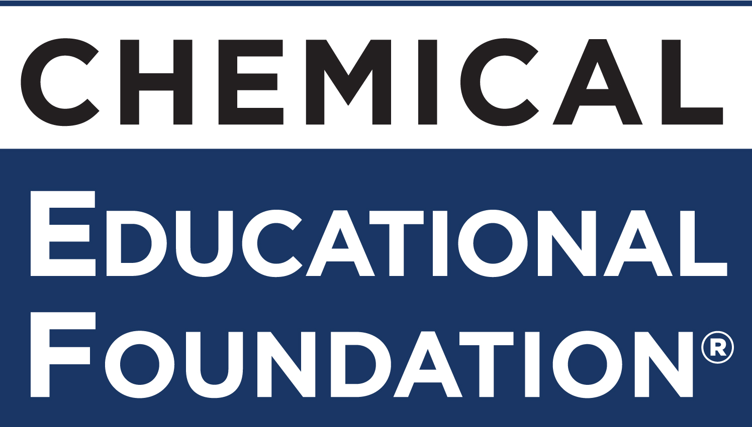
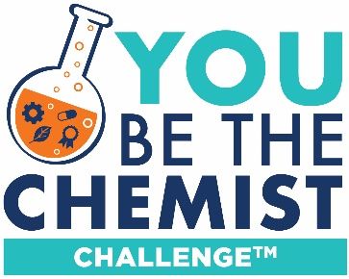

Participant Responsibilities
As a participant (“Participant”) in the You Be The Chemist Challenge® competition (“Challenge”), I have reviewed and will comply with the You Be The Chemist Challenge® Official Rules and any applicable Challenge format documents (the “Rules”), and I promise to conduct myself in accordance with any regulations on conduct set forth by the Challenge Organizers, officials, agents, and by the Chemical Educational Foundation® (CEF). I further understand that CEF reserves the right to terminate my participation in the Challenge for failure to comply with the Rules or instructions by CEF or Challenge Organizers. I hereby release and hold harmless CEF, Challenge Organizers and their respective officers, directors, employees, volunteers, agents, subsidiaries, sponsors, and affiliates, from any liability, loss, damage, claim, or expense claimed for any injury, loss, or damage of any kind suffered by any one of them arising out of or in any way relating to the Challenge and its associated activities, including, without limitation, any liability arising from any claimed negligent supervision.

Parent/Guardian Responsibilities
As the parent or legal guardian of Participant (“Parent/Guardian”), I will comply with the Rules and have reviewed them in full with Participant. I acknowledge that I am charged with the sole legal responsibility for the care of Participant during the Challenge and together with Participant hereby jointly and severally release, indemnify, and hold harmless CEF, Challenge Organizers and their respective officers, directors, employees, volunteers, agents, subsidiaries, sponsors, and affiliates, from any liability, loss, damage, claim, or expense claimed by Participant or by Parent/Guardian, on their own behalf, or on behalf of any one of them, for any injury, loss, or damage of any kind suffered by any one of them arising out of or in any way relating to the Challenge and its associated activities, including, without limitation, any liability arising from any claimed negligent supervision of Participant. I further understand that CEF reserves the right to terminate Participant’s participation in the Challenge for Participant and/or Parent/Guardian’s failure to comply with the Rules or instructions by CEF or Challenge Organizers.

Video Release
Participant and Parent/Guardian hereby grant CEF and Challenge Organizers, officials, sponsors, and agents a non-exclusive, royalty-free, unlimited, unrestricted, irrevocable, perpetual, worldwide, and absolute license to use, display, print, publish, distribute, reproduce, license, transfer, copy, edit, adapt, modify, perform, transmit and otherwise use any videos submitted for the YBTC Challenge competition by Participant and/or Parent/Guardian on behalf of Participant, including any derivative works created from such videos, in any manner or medium (whether now existing or hereafter developed) throughout the world in perpetuity without further permission and compensation of any kind, for any purposes associated with CEF or the Challenge, including, without limitation, the advertisement, marketing, promotion of CEF and the Challenge by CEF, Challenge Organizers or CEF’s sponsors and for any lawful purposes of CEF, Challenge Organizers and CEF’s sponsors. Participant and Parent/Guardian hereby grant permission to CEF and Challenge Organizers, officials, sponsors, and agents to use, display, print, publish, distribute, reproduce, perform, transmit and otherwise use the name and biographical information of Participant or Parent/Guardian in connection with the use of the video submitted for the National Challenge competition. Participant and Parent/Guardian represent that the submitted video: (1) is Participant’s own original work, created by the Participant, (2) does not infringe any third party proprietary rights, intellectual property rights, or privacy rights, and (3) does not contain content that is obscene, disparaging, defamatory, or otherwise inappropriate or unlawful. Participant and Parent/Guardian hereby jointly and severally release, indemnify, and hold harmless CEF, Challenge Organizers and their respective officers, directors, employees, volunteers, agents, subsidiaries, sponsors, and affiliates from any liability, loss, damage, claim, or expense arising out of the use of the video submitted for the National Challenge competition. Participant and Parent/Guardian acknowledge that Participant is not receiving any compensation for use of the video or Participant’s name and biographical information.

On behalf of the below minor, I have every right to contract for the Participant in the above regard. By completing this Participant Agreement (including the entering of the date and the names of Participant and Parent/Guardian in the signature lines below) and returning this Participant Agreement to CEF (and/or Participant’s school representative for the Challenge), Participant and Parent/Guardian (1) acknowledge that they have read and understand the terms of this Agreement in its entirety and (2) agree to the terms of this Participant Agreement.

AGREED:
__________________________ ___________________________________________________________
Date Participant Signature

__________________________ ___________________________________________________________
Date Parent/Guardian Signature

Participant Name: ___________________________________________________________________

Parent/Guardian Name: __________________________________________________________________

Relationship to Participant: ________________________________________________________________

E-mail: ___________________________________________________

School/Group Name: ________________________________________________

School Address: _____________________________________________________

City, State, Zip Code: _________________________________________________

